**Travel Management System**

Course of

**EXL- Certified Software Test Engineer**

Submitted By

**Aishwarya Kiran Shinde.**

**BATCH : 2022 - 7669**

ENROLLMENT NUMBER : EBEON0722634378

Under the Guidance of

**Ms. A. MOHANA PRIYA**

Centre Trainer****

**JANUARY - 2023**

**CONTENT**

**1.1 Content**

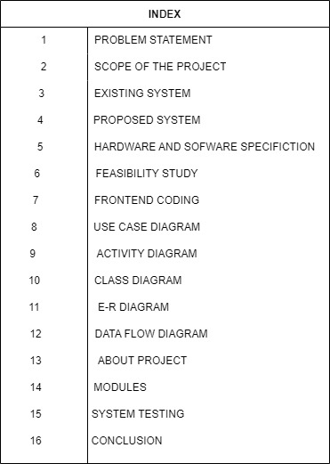

**INTRODUCTION**

**1. Introduction**

**1.1 Problem Statement :-**

This project aims to develop and Online Travel management for the users with the goal so that it is very easy to travel your most loved destination from a extensive number of Travel or Tourism places available on the country.

With the help of this you can carry out the or book your travel option or bus type from your home itself. Here is no compelling reason to go the crowded travel agency and bus stations to book tickets or choose your travel facility.

You simply require a Mobile and important payment sending option to book your tickets online to get to this online travel management system all the users will need to have an email and the password itself to login and proceed your booking. The login credentials for an Travel management system are under high security and nobody will have tendency to crack it easily.

**SCOPE AND OBJECTIVES**

**2. Scope and Objectives**

In Online Travel Management System is replace with existing system with the software solutions.

This System maintain details of users, different Travel Destinations and also Bus types with the features in the database.

It is more efficient and convenient for the customers. It reduces the manpower needed to perform the entire work. If all the work is done by computer there will no chance of errors.

More over storing and retrieving of the information is easy, and work be done speedily and in time.

Easy searching of destinations, users, and the Bus type information.

It efficient to choose the different bus type at any tie whenever we want.

This application is develop to provide best travelling services to the customers and travel agents. We have developed tours and travel management system to provide a search platform where a tourist can find their tour places according to their choices.

This system also helps to promote responsible and interesting tourism so that people can enjoy their holiday at their favorable places. This system also helps to develop tourism with different cultures so that they enrich the tourism experience and build pride.

We develop this system to create and promote forms of tourism that provide healthy interaction opportunities for tourists and locals and increase better understanding of different cultures , customs, lifestyles, traditional knowledge and believes. This system also provide a better way to connect with various events.

This system also gives tours related information likes which places are tourist attractions, cities, and provinces. Tourist can also get the map and navigation system and temperature and weather information.

Tourist can also book tours through our and travels management system. This system also keeps a history of visited places of its users.

**SYSTEM SPECIFICATION**

**3. System Specification**

**3.1 Hardware Requirements.**

Processors will continue to get faster, smaller and cheaper, whereas memory will continue to get faster, larger and cheaper. The trend except to have a reasonable memory to a powerful processor.

Processor : Intel Dual Core Processor

Ram : 1 GB RAM

Hard Drive : 160 GB

Monitor : 17 INCHES

Keyboard : 104 keys

Mouse : Logitech Optical Mouse

**3.2 System Configuration**

RAM : 4 GB

Hard Disk : 1 TB

**3.3 Software tools used :**

Language : HTML5, CSS3, PHP

Back-end used : Postgresql

**3.4 Software Requirements.**

When an application project is considered the three basis software requirements are the platform in which the project is developed the frontend tools that provides the interaction with the users and the back-end tools that stored the data.

Operating System : Windows 11

Front-end : Notepad, Bowser (Internet Explorer)

**3.3 Feature of Online Travel Management System**

1.Automating the Travel Booking.

2. Useful to find the most and good travel source.

3. It reduce the manpower.

4. Reduce the cost and time which taken by the existing system.

5. It very helpful to manipulate the data.

**SYSTEM DESIGN**

**4. System Design**

**4.1 Use Case Diagram**

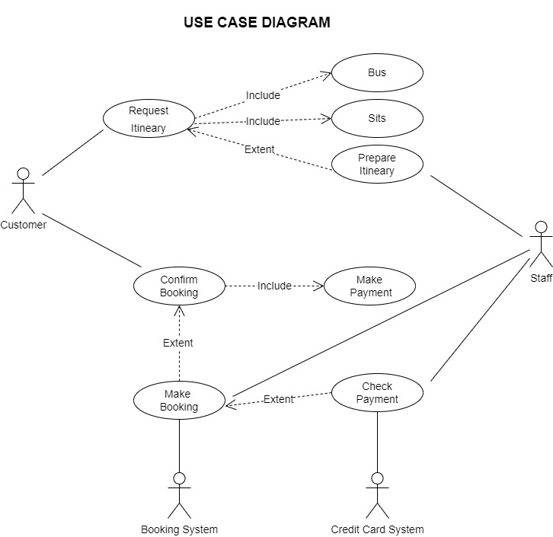

**4.1.1 Use case Descriptions**

A use case is a methodology used in system analysis to identify, clarify and organize system requirements. The use case is made up of a set of possible sequences of interactions between systems and users in a particular environment and related to a particular goal.

The method creates a document that describes all the steps taken by a user to complete an activity.

|  |  |  |  |
| --- | --- | --- | --- |
| **Sr. NO** | **USE CASE** | **ACTOR** | **DESCRIPTION** |
| 1. | Login | Administrator, Student (user) and Visitor. | Enter user name, and password |
| 2. | Registration | Administrator, Student (user) and Visitor. | First name, last name, email id, password. |
| 3. | Contact us | Administrator, Student (user) and Visitor. | First name, last name, email id, password, subject and comment box. |

**4.1.2 Use case Explanations**

In this use case diagram they mention the step process.

**4.1.3 Use case 001: login**

INTORDUCTION: this use case outlines the step that need to be followed in order to login into the system.

**Start**

ACTOR: Administrator, Student (user)

PRE-CONDITION: user has to have a valid credential

POST-CONDITION: the system display the relevant page

BASIC FLOW: the user enter the user name and password

|  |  |
| --- | --- |
| **ACTOR** | **SOFTWARE REACTION** |
| User Name  Password | If it is valid user can enter into system If it is invalid user it indicates it is wrong user name or password |

ALTERNATE FLOW: the user can enter the reg no

SPECIAL REQUIREMENTS: None

ASSOCIATED USE CASE(S): None

**4.1.4 Use case 002: Registration**

INTORDUCTION: this use case outlines the step that need to be followed in order to register form

ACTOR: student (user) and admin.

PRE-CONDITION: user has to have a valid credential

POST-CONDITION: the system display the relevant page

BASIC FLOW: the system confirms that the entered details is correct or not.

**Scenario:**

|  |  |
| --- | --- |
| **ACTOR** | **SOFTWARE REACTION** |
| First name  Last name  Email id  Password | The system verifies that the above items has been filled out If any data is missing, the system warns the user and the steps continues with software reaction  If all data has been entered the system ask the user to view the result.  If the user indicate they want to end the scenario here  And If the user indicate that their marks are not correct the scenario continues with software reaction. |

ALTERNATE FLOW: None

SPECIAL REQUIREMENTS: None

ASSOCIATED USE CASE(S): None

**4.1.5 Use case 003: Contact us**

INTORDUCTION: this use case outlines the step that need to be followed in order to fill out the data

ACTOR: s

student (user) and admin

PRE-CONDITION: user has to have a valid credential

POST-CONDITION: the system display the relevant page

BASIC FOLW: the user enter the details

|  |  |
| --- | --- |
| **ACTOR** | **SOFTWARE REACTION** |
| First name  Last name  Email id  Password Subject  Comment | The system verifies that the above items has been filled out  If any data is missing, the system warns the user and the steps continues with software reaction  If all data has been entered the system ask the user to view the result.  If the user indicate they want to end the scenario here  And If the user indicate that their marks are not correct the scenario continues with software reaction. |

ALTERNATE FLOW: click the help option

SPECIAL REQUIREMENTS: None

ASSOCIATED USE CASE(S): None **4.2 Activity Diagram**

An activity diagram shows Online and Software processes as a progression of action.

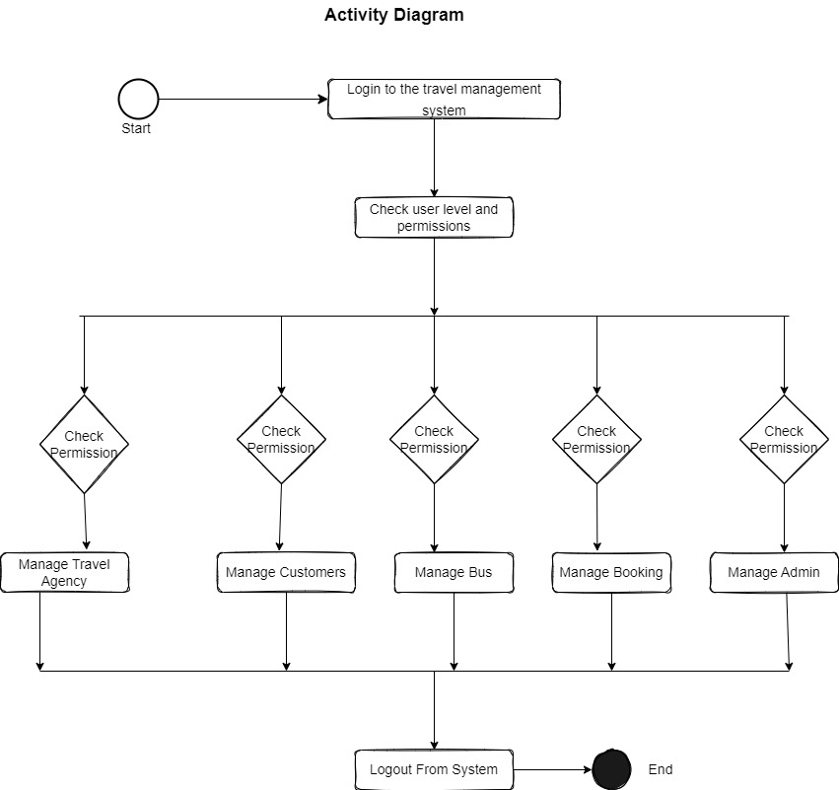

**4.3 Class Diagram**

The purpose of class diagram is to model the static view of an application . Class diagrams are the only diagrams which can be directly mapped with object – oriented languages and thus widely used at the time of construction.

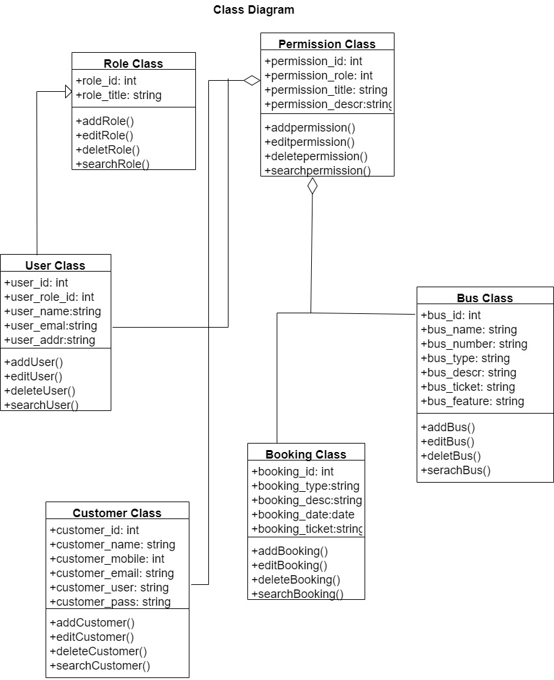

**4.4 Entity Relational Diagram (ER)**

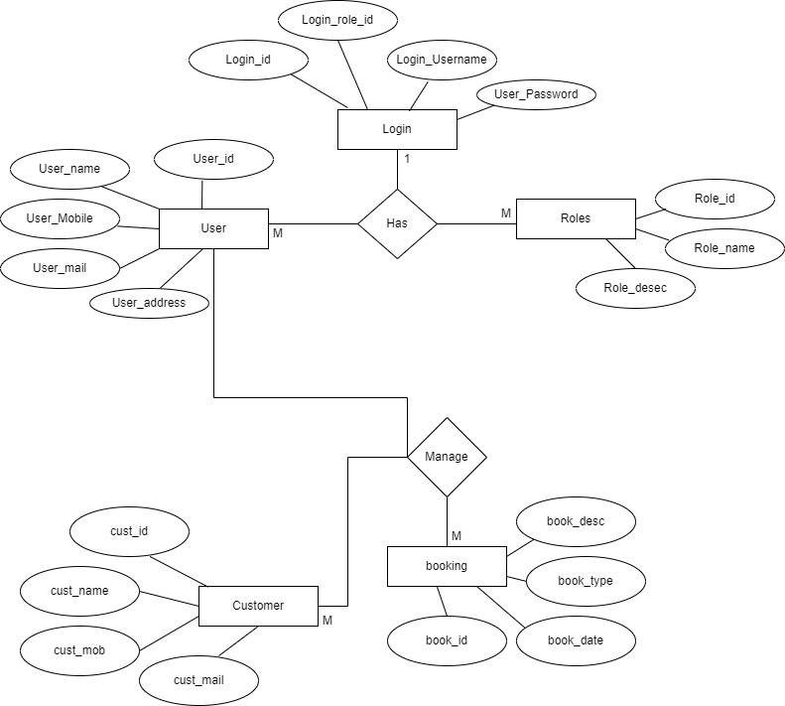

**4.5 Data Flow Diagram**

A data flow diagram is a graphical model the show of the main requirement for an information system in a diagram : input and output, process, and data storage.

Describe what data flow rather than how to processed. Everyone working on a development project can see all aspect of the system working

Together at once with DFD. That is one of the reason for its popularity, the DFD is also easy. To read because it is graphical model. The DFD is mainly used during problem analysis. End DFD with minimal training.

**4.5.1 DFD Symbol**

1. Process

2. Data Flow

3. External Entity

4. Data Store

**4.5.2 Data Flow Diagram**

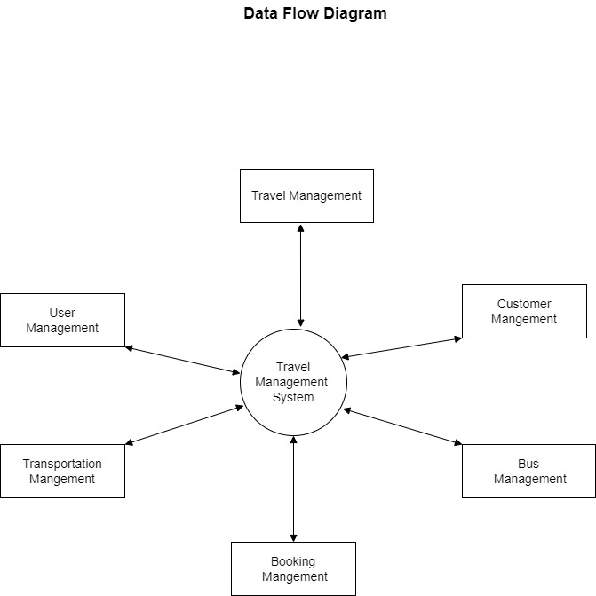

**4.6 Table Structure**

**4.6.1 Login**

Table name: login

Primary key: email id

|  |  |  |
| --- | --- | --- |
| **COLUMN NAME** | **DATA TYPE** | **DESCRIPTION** |
| EMAIL ID | TEXT | EMAIL ID |
| PASSWORD | NUMBER | PASSWORD |

**4.6.2 Register**

Table Name: Register

Primary key: email id

|  |  |  |
| --- | --- | --- |
| **COLUMN NAME** | **DATA TYPE** | **DESCRIPTION** |
| FIRST NAME | TEXT | FIRST NAME |
| LAST NAME | TEXT | LAST NAME |
| EMAIL ID | TEXT | EMAIL ID |
| COMFORM PASSWORD | NUMBER | COMFORM PASSORED |

**4.6.3Contact us**

Table Name: Contact us

Primary key: email id

Foreign Key: Comment box

|  |  |  |
| --- | --- | --- |
| **COLUMN NAME** | **DATA TYPE** | **DESCRIPTION** |
| FIRST NAME | TEXT | FIRST NAME |
| LAST NAME | TEXT | LAST NAME |
| EMAIL ID | TEXT | EMAIL ID |
| BUS TYPE | TEXT | BUS TYPE |

**IMPLEMENTATION**

**5. Implementation**

**5.1 Modules**

In this web site I created the online Travel Management System for the better way of choose or book tickets online.

And find the convenient source of Travelling**.**

In this particular web page I included Home, About us and Content.

**5.1.1 Home**

“ Welcome to Online Bus Reservation System” choose and explore .

This is the quotation of Home Page. It is representing the online travel system where we can choose our convenient source of travelling , with advance feature as per our requirements.

**5.1.2 About Project**

It is an Frontend as well as the Backend web page for the Bus/Travel Management System, If we want to go some Destination then this web page will helps customers to choose their appropriate Bus type with the Bust features and with the negotiable prize. They can book their tickets with the help of online mode also. With the help of this web page customers also choose their comfortable travel bus. And here they can also contact to the owner of the Travel Agency.

**5.1.3 Registration**

In this particular web page first we have to find the our source and destination. After that we have to register and choose which type of travelling we want. We can also see the different feature of that bus. If some time we want to directly talk with the owner then it is also possible in this particular web page.

**5.1.4 Contact us**

Online travel management system gives us features to directly contact with them in case of some conflict happens. Then we can directly contact with them with the help of contact us .

**5.2 Language Used**

I have Used HTML, CSS, PHP to develop the front-end page.

**5.2.1 HTML (Hypertext Markup Language)**

**HTML** stands for Hyper Text Markup Language. It is used to design web pages using a markup language. HTML is the combination of Hypertext and Markup language. Hypertext defines the link between web pages. A markup language is used to define the text document within the tag which defines the structure of web pages.

language is used to annotate (make notes for the computer) text so that a machine can understand it and manipulate text accordingly. Most markup languages (e.g. HTML) are human-readable. The language uses tags to define what manipulation has to be done on the text.

1.HTML Modules (.html) 2.PHP Modules

**5.2.2 HTML page structure**

The basic structure of an HTML page is laid out below. It contains the essential building-block elements (i.e. doctype declaration, HTML, head, title, and body elements) upon which all web pages are created.

• It is easy to learn and easy to use.

• It is platform-independent.

• Images, videos, and audio can be added to a web page.

• Hypertext can be added to the text.

• It is a markup language.

**5.2.3 CSS ( Cascading Style Sheet )**

Cascading Style Sheets, fondly referred to as CSS, is a simply designed language intended to simplify the process of making web pages presentable. CSS allows you to apply styles to web pages. More importantly, CSS enables you to do this independent of the HTML that makes up each web page.

CSS lets developers and designers define how it behaves, including how elements are positioned in the browser. While html uses tags, css uses rulesets. CSS is easy to learn and understand, but it provides powerful control over the presentation of an HTML document.

**5.2.4 Types**

**• CSS saves time:**

You can write CSS once and reuse the same sheet in multiple HTML pages.

**• Easy Maintenance:**

To make a global change simply change the style, and all elements in all the webpages will be updated automatically.

**• Search Engines:**

CSS is considered a clean coding technique, which means search engines won’t have to struggle to “read” its content.

**• Superior styles to HTML:**

CSS has a much wider array of attributes than HTML, so you can give a far better look to your HTML page in comparison to HTML attributes.

**• Offline Browsing:**

CSS can store web applications locally with the help of an offline cache. Using this we can view offline websites.

**5.2.5 JavaScript**

**JavaScript** is a lightweight, cross-platform, and interpreted compiled programming language which is also known as the scripting language for webpages. It is well-known for the development of web pages, many non-browser environments also use it.

JavaScript can be used for CLIENT-SIDE developments as well as SERVER_SIDE developments.

JavaScript is both imperative and declarative type of language. JavaScript contains a standard library of objects, like array, date and math, and a core set of language elements like **operators, control structures,** and **statements.**

**5.2.6 Client-side:**

It supplies objects to control a browser and its Document Object Model (DOM). Like if client-side extensions allow an application to place elements on an HTML form and respond to user events such as **mouse clicks, form input,** and **page navigation.**

**CODING**

**6. Coding**

<html>

<head>

<meta name="viewport" content="width=device-width, initial-scale=1">

<style>

body

{

background-color:lightblue;

font-size:italic;

padding: 14px 16px;

}

</style>

<style>

#b1{

background-color:purple;

width:600px;

height:300px;

border:2px solid black;

text-align:auto;

margin:auto;

}

#c1{

background-color:powderblue;

width:500px;

height:200px;

border:2px solid black;

margin-left:50px;

margin-top:50px;

}

#d{

background-color:lightpink;

width:300px;

height:30px;

border:2px solid black;

text-align:center;

margin-left:100px;

margin-top:60px;

height:30px;

}

#e{

background-color: lightpink;

width:300px;

height:30px;

border:2px solid black;

text-align:center;

margin-left:100px;

margin-top:20px;

height:30px;

}

h1{

text-align:center;

}

</style>

<style>

body {

margin: 0;

font-family: Arial, Helvetica, sans-serif;

}

.topnav {

overflow: hidden;

background-color: grey;

margin: 3px;

border-radius: 2px;

}

.topnav a {

float: right;

display: block;

color: black;

text-align: center;

padding: 14px 16px;

text-decoration: none;

font-size: 17px;

}

.topnav a:hover {

background-color: #ddd;

color: rgb(0, 0, 0);

}

.topnav a.active {

background-color: black;

color: blue;

}

</style>

</head>

<body>

<div class="topnav" id="myTopnav">

<a href="#Contact">Contact</a>

<a href="#About">About</a>

<a href="#Schedule">Schedule</a>

<a href="#home" class="active">Home</a>

</a>

</div>

</body>

<body>

<h1 id=a> Welcome to Bus Reservation System </h1>

<div id=b1>

<div id=c1>

<div id=d> FORTUNE TRAVEL COMPANY </div>

<div id=e> BusIndia On Mobile </div>

</div>

<div>

</body>

</html>

<br><br>

<!DOCTYPE html>

<html>

<style>

body

{

padding : 50px 50px;

margin : 50px 50px;

}

</style>

<style>

body

{

background-color:CadetBlue;

}

</style>

<body>

<h1> <b><i><p> Fortune Travel Company </p></i></b></h1>

<h2><i><p> An Exciting Journey is Here <p></i></h2>

<img src= "C:\Users\AYUSH\Downloads\images.jpeg" width="1200" height="700">

</body>

</html>

<br><br>

<i><h2><caption> Explore Your WildLife Destination </caption></h2></i>

<!DOCTYPE html>

<html>

<style>

body

{

padding : 50px 50px;

margin : 50px 50px;

}

</style>

<style>

body

{

background-color: Cadetblue;

}

</style>

<body>

<img src="C:\Users\AYUSH\Downloads\images (1).jpg" width="1200" height="700">

</body>

</html>

<br><br>

<canvas id="can1" width="200" height="100"></canvas>

<!DOCTYPE html>

<html>

<!--<caption><b><h1><i> Travel Registration Form </i></h1></b></caption> -->

<h1 text-align:center style ="background-color:linen;"> Travel Registration Form </h1>

<style>

body

{

background-color:azure;

font-style : italic;

float:left;

padding:14px 16px;

}

</style>

<body>

<style>

.Hi

{

color:orange;

text-align:right;

font-sixe:10px;

font-family:italic;

}

</style>

<style>

.By

{

color:pink;

text-align:right;

font-sixe:10px;

font-family:italic;

</style>

<b> First Name: </b><input type="text" name="First Name"/>

<br><br>

<b> Last Name: </b> <input type="text" name="Last Name"/>

<br><br>

<b> Email: </b> <input type="text" name="Email id"/>

<br><br>

<b>Hometown City: </b><select name="Hometown City"><br>

<option value ="pune"=>pune</option>

<option value ="Bangluru"=>Bangluru</option

<option value ="Mumbai"=>Mumbai</option>

<option value ="Hydrabad"=>Hydrabad</option>

<option value ="Nashik"=>Nashik</option>

<option value ="Ludhiyana"=>Ludhiyana</option>

</select>

<br><br>

<b>Destination: </b><select name="Destination"><br>

<option value ="Bangluru"=>Bangluru</option>

<option value ="Mumbai"=>Mumbai</option>

<option value ="Hydrabad"=>Hydrabad</option>

<option value ="Nashik"=>Nashik</option>

<option value ="Ludhiyana"=>Ludhiyana</option>

</select>

<br><br>

<b>Bus Type: </b> <select name="Bus Type">

<option value="Normal">Normal</option>

<option value="AC">AC</option>

<option value="Non AC> Non AC</option>

<option value="Sleeper Coach">Sleeper Coach</option>

</select>

<br><br>

<caption><b> Payment Mode </b></caption><br>

<input type="checkbox" name="Payment Mode" value="Online">Online

<br>

<input type="checkbox" name="Payment Mode" value="Cash"> Cash

<br>

<input type="checkbox" name="Payment Mode" value="Check"> Check

<br><br>

<b>Phone<b/>: <input type="text" name="Phone"/>

<br><br>

<b>Gender</b>:<input type="radio" name="Sex" value="Male">Male

<input type="radio" name="Sex" value="Female">Female

<br><br>

<b> <input type ="submit" class = "Hi" name = "submit" values ="submit"/></b>

<b> <input type = "reset" class = "By" name = "reset" values = "Reset"/></b>

</head>

</body>

</html>

<br><br>

<!DOCTYPE html>

<html>

<style>

body

{

padding : 50px 50px;

margin : 50px 50px;

}

</style>

<style>

body

{

background-color: Cadetblue;

}

</style>

<body>

<h2><i><caption> Start your Journey with Us </caption></i></h2>

<img src= "C:\Users\AYUSH\Downloads\images.jpg" width="1300" height="800">

</body>

</html>

<br><br>

<!DOCTYPE html>

<html>

<h1>Contact Us </h1>

<h3 text-align:center style ="background-color:linen;"> Contact Details </h3>

<style>

body

{

background-color:lightblue;

font-style : italic;

}

</style>

<body>

<style>

.Hi

{

color:orange;

text-align:right;

font-size:20px;

font-family:italic;

}

</style>

<style>

.Hello

{

color:blue;

text-align:right;

font-size:20px;

font-family:italic;

}

</style>

<b> First Name:</b> <input type="text" name="First Name"/><br><br>

<b> Last Name:</b> <input type="text" name="Last Name"/><br><br>

<b> Email Id:</b> <input type="text" name="Email Id"/><br><br>

<b> Contact:</b> <input type="text" name="Contact"/><br><br>

<input type="submit" class="Hi" name="Submit" values="Submit"/>

<input type="reset" class="Hello" name="Reset" values="Reset"/>

</body>

</html>

**6.2 Screenshots**

**Module 1 :-** Home Page

This Home page contains the Travel Agency Name “Fortune Travel Company” and the Slogan the slogan “ BusIndia On Mobile” at the top, there is the Navigation bar there is indicates the Schedule, About, Contact Pages.

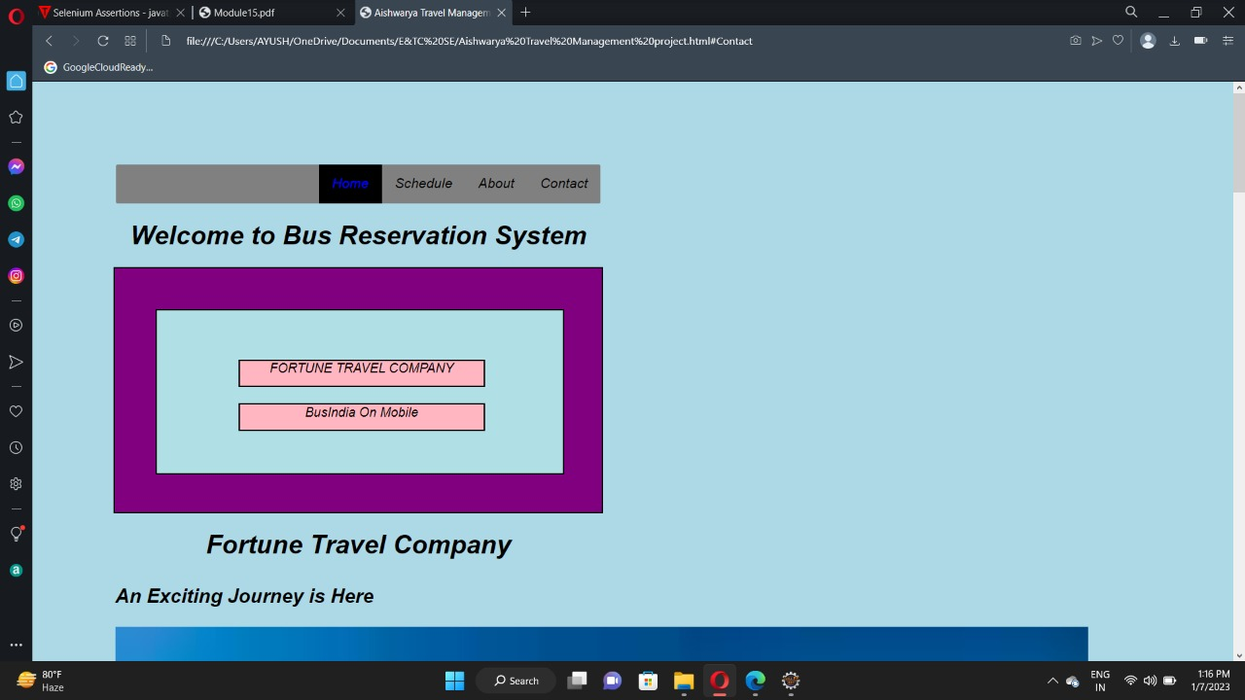

**Module 2:-**

This About page contains the some information and the pictures of the popular destinations for the tourist.

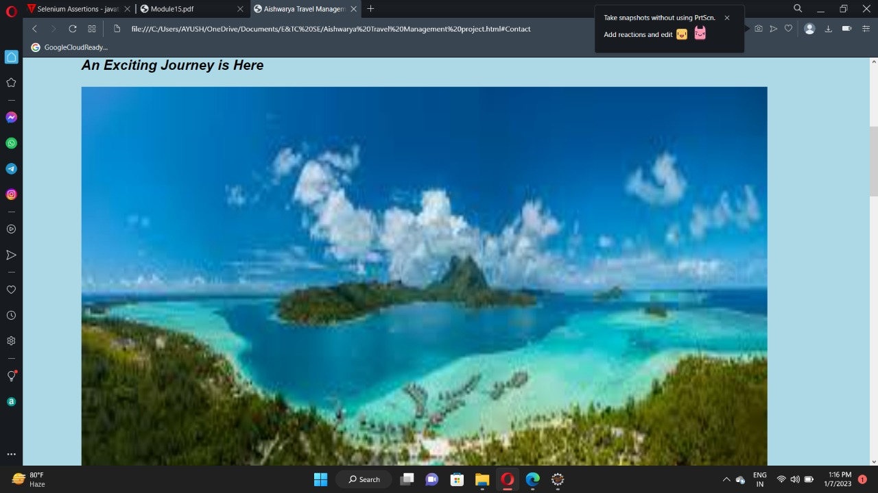

**Module 3 :-** Travel Registration Form

Registration form contains information which will be collect from the user for the security purpose. Information contain Name, Email, Hometown City, User Destination, There fav bus type with the bus features. User payment mode and the contact number with their gender. This information will be store at the Travel agency side.

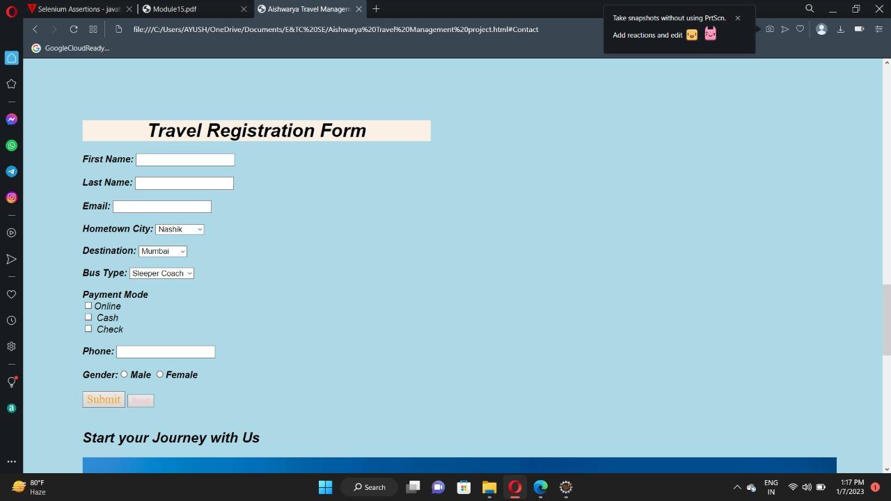

**Module 4 :-** Contact Page

Contact page is use for the user purpose if they have any problem or some issue with the travelling them they will contact to the owner with the help of the contact page.

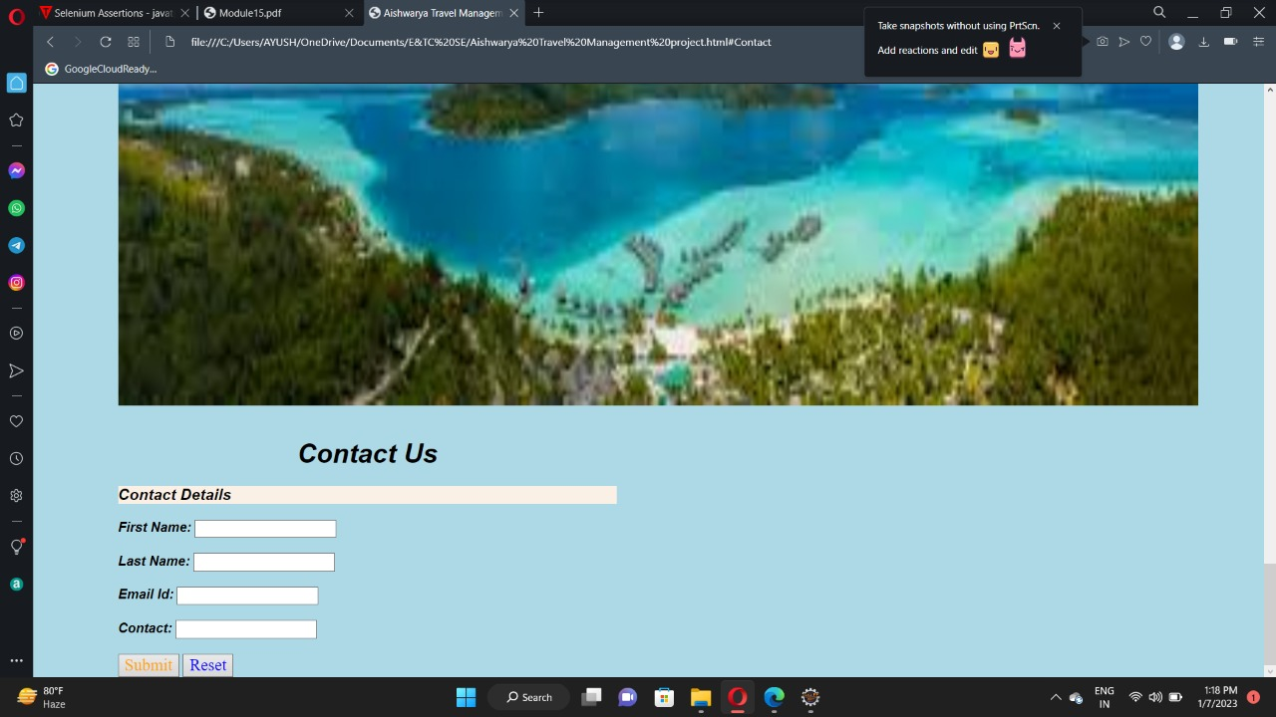

**SYSTEM TESTING**

**6.System Testing**

**6.1 Selenium**

Selenium is one of the most widely used open source Web UI (User Interface) automation testing suite. It was originally developed by Jason Huggins in 2004 as an internal tool at Thought Works. Selenium supports automation across different browsers, platforms and programming languages. Selenium can be easily deployed on platforms such as Windows, Linux, Solaris and Macintosh. Moreover, it supports OS (Operating System) for mobile applications like iOS, windows mobile and android. Selenium supports a variety of programming languages through the use of drivers specific to each language.

Languages supported by Selenium include **C#, Java, Perl, PHP, Python** and **Ruby.** Currently, Selenium Web driver is most popular with Java and C#. Selenium test scripts can be coded in any of the supported programming languages and can be run directly in most modern web browsers. Browsers supported by Selenium include **Internet Explorer, Mozilla Firefox, Google Chrome and Safari.**

Selenium Grid

Selenium WebDriver

Selenium RC

Selenium IDE

Selenium Suit

Selenium can be used to automate functional tests and can be integrated with automation test tools such as **Maven, Jenkins, & Docker** to achieve continuous testing.

It can also be integrated with tools such as **TestNG, & JUnit** for managing test cases and generating reports.

**6.2 Testing**

Testing is very vital for any system to be successfully implemented. The common view is that it is performed to prove that there are no errors in a program. Therefore the most useful and practical approach is with the explicit intention of finding the errors. The system is tested experimentally to ensure that the software does not fail. The system is run according to its specifications and in the way the user expects. Following testing practices are used. The system will process as normal input preparation of test-sample data.

System Testing is a level of testing that validates the complete and fully integrated software product. The purpose of a system test is to evaluate the end-to-end system specifications.

Usually, the software is only one element of a larger computer-based system. Ultimately, the software is interfaced with other software/hardware systems.

System Testing is defined as a series of different tests whose sole purpose is to exercise the full computer-based system.

Two Category of Software Testing

• Black Box Testing

• White Box Testing

System test falls under the **black box testing** category of software testing.

**White box testing** is the testing of the internal workings or code of a software application. In contrast, black box or System Testing is the opposite. System test involves the external workings of the software from the user’s perspective.

**6.2.1 Testing Methodology**

Software Testing Methodology is defined as strategies and testing types used to certify that the Application under Test meets client expectations.

Test Methodologies include functional and non-functional testing to validate the AUT. Examples of Testing Methodologies are Unit Testing, Integration Testing, System Testing, Performance Testing etc.

Each testing methodology has a defined test objective, test strategy, and deliverables. There are tons of methodologies available for software development and its corresponding testing. Each testing technique and methodology is designed for a specific purpose and has its relative merits and demerits.

Selection of a particular methodology depends on many factors such as the nature of a project, client requirement, project schedule, etc.

From a testing perspective, some methodologies push for testing input early in the development life cycle, while others wait until a working model of the system is ready.

**6.2.2 Equivalence Partitioning**

Equivalence classes are evaluated for given input conditions. Whenever any input is given, then type of input condition is checked, then for this input conditions, Equivalence class represents or describes set of valid or invalid states.

This technique tries to define test cases that uncover classes of errors, thereby reducing the total number of test cases that must be developed. An advantage of this approach is reduction in the time required for testing software due to lesser number of test cases.

Equivalence partitioning is typically applied to the inputs of a tested component, but may be applied to the outputs in rare cases. The equivalence partitions are usually derived from the requirements specification for input attributes that influence the processing of the test object.

**6.2.3 Software level testing can be majorly classified into 4 levels:**

**1. Unit Testing:** A level of the software testing process where individual units/components of a software/system are tested. The purpose is to validate that each unit of the software performs as designed.

**2. Integration Testing:** A level of the software testing process where individual units are combined and tested as a group. The purpose of this level of testing is to expose faults in the interaction between integrated units.

**3. System Testing:** A level of the software testing process where a complete, integrated system/software is tested. The purpose of this test is to evaluate the system’s compliance with the specified requirements.

**4. Acceptance Testing:** A level of the software testing process where a system is tested for acceptability. The purpose of this test is to evaluate the system’s compliance with the business requirements and assess whether it is acceptable for delivery.

**6.3 STRATERGIES FOR TESTING**

**6.3.1 Unit Testing**

Each and every module was intensively tested to check for errors and defects. All possible mistakes were rectified. Manually code is tested like logical errors.

Once the manual checking is over the compilation has been done. Syntactical error if any has to be corrected.

After the clean compilation of the program, some dummy data as per specifications has been used for testing of that module to see if it works as specified.

**6.3.2 Integration Testing**

Integration testing uncovers errors that arise when modules are integrated to build the overall system.

The purpose of integration testing is to detect any inconsistencies between the software units that are integrated together (called assemblages).

All the unit tested modules were integrated & the errors that occurred were removed and the overall program structure was build as specified by the design.

**6.3.3 System Testing**

System testing of software or hardware is testing conducted on a complete, integrated system to evaluate the system's compliance with its specified requirements. System testing falls within the scope of black box testing, and as such, should require no knowledge of the inner design of the code or logic.

System testing is used to detect defects both within the "inter-assemblages" and also within the system as a whole.

**6.3 Testcase**

**Testcase for Travel Management System Website.**

Project Name :- Travel Management System.

Reference :- Project Functionality Requirement Specification

Created By :- <http://www.Fourtunetravel.com>

Date of created :- 10-October -2022

Date of review :- 19-January -2023.

**6.5 Test Case**

|  |  |  |  |  |  |  |  |
| --- | --- | --- | --- | --- | --- | --- | --- |
| **Test Case ID** | **Test Case Name** | **Test Case Description** | **Step** | **Executed Result** | **Actual** | **Test Case Status** | **Priority** |
| Login | Validate  fields | To verify appropriate user login | Enter number or special characters | Invalid Username or password | Error Message | Designed | High |
| Employee  Details | Validate  fields | To Verify all the fields are filed | Leave any field empty | Add & Update button disabled | Button Disabled | Designed | Medium |
| Reservation Details | Validate  fields | To Verify all the fields are filed | Leave any field empty | Add & Update button disabled | Button Disabled | Designed | Medium |
| Cancellation Details | Validate  fields | To Verify all the fields are filed | Leave any field empty | Add & Update button disabled | Button Disabled | Designed | Medium |
| Concession Details | Validate  fields | To Verify all the fields are filed | Leave any field empty | Add & Update button disabled | Button Disabled | Designed | Medium |

**6.7 Website Automation Testing Using Selenium**

Automation Testing is a software testing technique that performs using special automated testing software tools to execute a test case suite.

On the contrary, Manual Testing is performed by a human sitting in front of a computer carefully executing the test steps.

The automation testing software can also enter test data into the System Under Test, compare expected and actual results and generate detailed test reports.

Software Test Automation demands considerable investments of money and resources.

**6.4.1 Automation testing process:**

Following steps are followed in an Automation Process

**Step 1**. Test Tool Selection

**Step 2.** Define scope of Automation

**Step 3**. Planning, Design and Development

**Step 4.** Test Execution

**Step 5**. Maintenance

**6.4.2 Selenium Automation**

Selenium is a free, open-source automation testing suite for web applications across different browsers and platforms.

It is somewhat similar to HP Quick Test Pro (QTP, currently UFT). However, Selenium focuses on automating web-based applications.

Testing done using Selenium is usually referred to as Selenium testing. Remember, only testing web applications is possible with Selenium. You cannot use it to test desktop applications or mobile applications.

I have created an website for online Travel Management System.

And I have done test Automation on my project by using selenium and the syntax for testing my website.

**6.5 Selenium Code for Travel Management System**

package selenium1p;

import org.openqa.selenium.By;

import org.openqa.selenium.WebDriver;

import org.openqa.selenium.WebElement;

import org.openqa.selenium.chrome.ChromeDriver;

public class online{

public static void main(String[] args) {

System.setProperty("webdriver.gecko.driver","C:\\Users\\Aish\\Downloads\

\chromedriver_win32\\chromedriver.exe");

WebDriver driver = new ChromeDriver();

//URL launch

driver.get("<http://www.Fourtunetravel.com> ");

//identify username

WebElement l = driver.findElement(By.name("username"));

l.sendKeys("Pass@gmail.com");

//identify password

WebElement p = driver.findElement(By.name("password"));

p.sendKeys("Pass@1234");

WebElement b = driver.findElement(By.className("Igw0E"));

b.click();

//obtain value entered for username

String s = l.getAttribute("value");

System.out.println("Value entered for username: " + s);

//quit browser

driver.quit();

}

}

**6.6 Output**

1) Home Page



In above figure we can able to view about page.

2) Login page

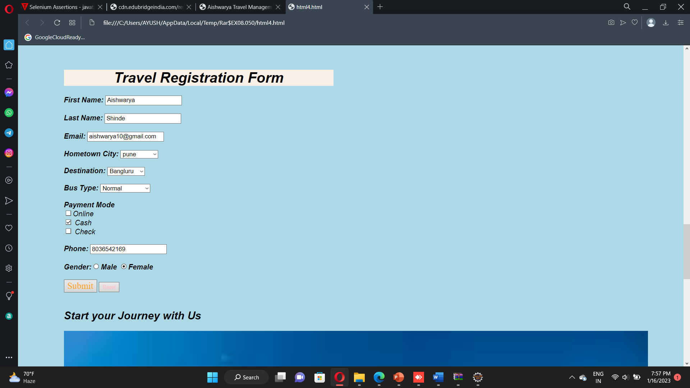

In above figure we can able to view login page

**CONCLUSION**

**Conclusion:-**

"Travel Management Project" is mainly deals with the online bus or travel registration system. with the help of this web page users can direct book and choose the feature of bus or travelling type. They can also choose different types of bus types with there feature. Online Travel Management encounter problem of traditional reservation system, where customer have to wait in a queue for get the tickets and in that way they can't able to choose there fav travelling source. It’s mainly solve the problem of the travel brokerage and helps customer and gives smooth experience and it also helps the travel owners to increase there sales and services. In Online Travel Management System Data Manipulation and data storage is very easy and secure.